CS 342302 Operating Systems
Fall Semester 2021
Prof. Pai H. Chou

Weekly Review 12
Scope: Chapter 11, Mass-Storage Systems

1. Definitions and Short Answers
- Name the following parts of a disk (a - h) and the motions (i - j).
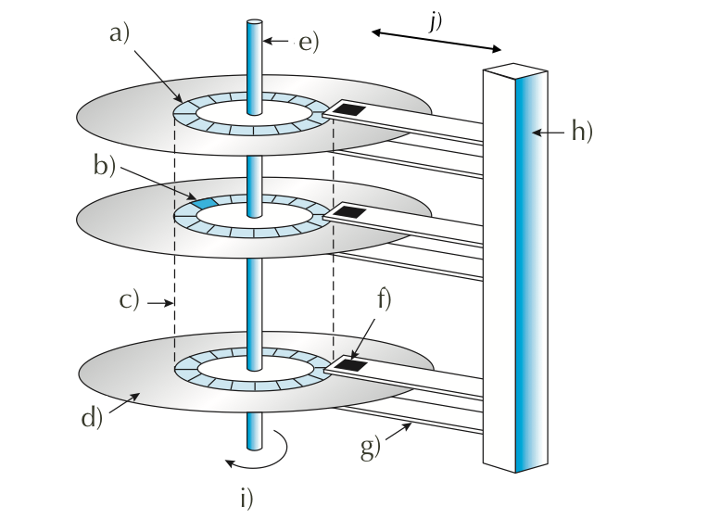
- When accessing data on a magnetic disk,
  - What is the rotational latency?
  - What is the seek time?
  - What is the positioning time?
  - What is another word for the positioning time?
  - What are the two components of positioning time in magnetic disk access?
- What is the difference between a cylinder and a track?

- For flash memory terminology, assume NAND flash,
  - What is the minimum unit of reading?
  - What is the minimum unit of writing?
  - What is a block?
  - What happens during an erase?
  - If you have to modify one byte, what are the steps involved?
- What is wear-leveling, and why is it important for flash memory?
- What is the primary action that an OS can schedule to improve the performance of a hard disk drive?
- Of the different disk scheduling algorithms,
  - is FIFO in general a good policy for HDD? for SSD?
  - is STSF in general a good policy for HDD? What kind of problem does it have? What about for SSD?
  - What is the difference between SCAN and C-SCAN?
  - What is the difference between SCAN and LOOK?
  - Why does SCAN have more predictable behavior than LOOK?
- If NVM scheduling does not need to consider rotation or seek time, what does it need to consider?
- What is a spare sector?
- What is sector-slipping?
- Can a regular file system be used for swap space? What are the advantages and disadvantages?
- What is a swap partition, and why is it a good idea?
- how do you pronounce SCSI?
- What does RAID stand for?
- How can RAID achieve higher reliability?
- How can RAID achieve higher disk performance? In what metric?
- What is the meaning of the following about disks?
  - mean time to failure
  - mean time to repair, and is it related to mean time to failure?
  - mean time to data loss
- What is the meaning of
  - mirroring?
  - data striping? Is it related to mirroring?
  - What is the difference between bit-level and block-level striping? which is more common?
  - What is the meaning of striped mirror? mirrored stripes? Which one is a better choice?

2. Programming Exercise

3. Disk Scheduling Algorithms [25 points]

You are to implement the disk (seek) scheduling algorithms covered in Chapter 11.

Use the following template (download and rename as disk.py):

class DiskScheduler:
_POLICIES = ['FCFS', 'SSTF', 'SCAN', 'LOOK', 'C-SCAN', 'C-LOOK']

def __init__(self, nCylinders):
self.nCylinders = nCylinders

def schedule(self, initPos, requestQueue, policy, direction):
'''
request is the list of cylinders to access
policy is one of the strings in _POLICIES.
direction is 'up' or 'down' and applies to (C-)SCAN/LOOK only.
returns the list for the order of cylinders to access.
'''
if policy == 'FCFS':
# return the disk schedule for FCFS
if policy == 'SSTF':
# compute and return the schedule for shortest seek time first
if policy in ['SCAN', 'C-SCAN', 'LOOK', 'C-LOOK']:
# sequentially one direction to one end (up or down),
# then sequentially in opposite direction.
# compute and return the schedule accordingly.

def totalSeeks(initPos, queue):
lastPos = initPos
totalMoves = 0
for p in queue:
totalMoves += abs(p - lastPos)
lastPos = p
return totalMoves

if __name__ == '__main__':
def TestPolicy(scheduler, initHeadPos, requestQ, policy, direction):
s = scheduler.schedule(initHeadPos, requestQ, policy, direction)
t = totalSeeks(initHeadPos, s)
print('policy %s %s (%d): %s' % (policy, direction, t, s))

scheduler = DiskScheduler(200)
requestQueue = [98, 183, 37, 122, 14, 124, 65, 67]
initHeadPos = 53
for policy in DiskScheduler._POLICIES:
if policy[:2] == 'C-' or policy[-4:] in ['SCAN', 'LOOK']:
TestPolicy(scheduler,initHeadPos, requestQueue, policy, 'up')
TestPolicy(scheduler,initHeadPos, requestQueue, policy, 'down')
else:
TestPolicy(scheduler, initHeadPos, requestQueue, policy, '')

print('more tests on SCAN and C-SCAN')
rQs = [[98, 37, 0, 122, 14], [98, 37, 199, 122, 14], [98,0,37,199,14]]
for q in rQs:
print('Q=%s' % q)
for policy in ['SCAN', 'C-SCAN']:
for direction in ['up', 'down']:
TestPolicy(scheduler, initHeadPos, q, policy, direction)

You can expect to get output like this:

$ python3 disk.py
policy FCFS (640): [98, 183, 37, 122, 14, 124, 65, 67]
policy SSTF (236): [65, 67, 37, 14, 98, 122, 124, 183]
policy SCAN up (331): [65, 67, 98, 122, 124, 183, 199, 37, 14]
policy SCAN down (236): [37, 14, 0, 65, 67, 98, 122, 124, 183]
policy LOOK up (299): [65, 67, 98, 122, 124, 183, 37, 14]
policy LOOK down (208): [37, 14, 65, 67, 98, 122, 124, 183]
policy C-SCAN up (382): [65, 67, 98, 122, 124, 183, 199, 0, 14, 37]
policy C-SCAN down (386): [37, 14, 0, 199, 183, 124, 122, 98, 67, 65]
policy C-LOOK up (322): [65, 67, 98, 122, 124, 183, 14, 37]
policy C-LOOK down (326): [37, 14, 183, 124, 122, 98, 67, 65]
more tests on SCAN and C-SCAN
Q=[98, 37, 0, 122, 14]
policy SCAN up (345): [98, 122, 199, 37, 14, 0]
policy SCAN down (175): [37, 14, 0, 98, 122]
policy C-SCAN up (382): [98, 122, 199, 0, 14, 37]
policy C-SCAN down (353): [37, 14, 0, 199, 122, 98]
Q=[98, 37, 199, 122, 14]
policy SCAN up (331): [98, 122, 199, 37, 14]
policy SCAN down (252): [37, 14, 0, 98, 122, 199]
policy C-SCAN up (382): [98, 122, 199, 0, 14, 37]
policy C-SCAN down (353): [37, 14, 0, 199, 122, 98]
Q=[98, 0, 37, 199, 14]
policy SCAN up (345): [98, 199, 37, 14, 0]
policy SCAN down (252): [37, 14, 0, 98, 199]
policy C-SCAN up (382): [98, 199, 0, 14, 37]
policy C-SCAN down (353): [37, 14, 0, 199, 98]

